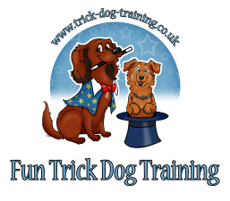**Party booking form**

**Your Details**

Full name:…………………………………………………………………………………………………………………………………………………………

Address:……………………………………………………………………………………………………………………………………………………………

Phone:………………………………………………………Email:..………………………………………………………………………………………….

Brief Description of your event: …………………………………………………………………………………………………………………………………………………………….…………..………………………………………………………………………………………………………………………………………………….……………………..……………………………………………………………………………………………………………………………………….………………………………..

Date and time of the event: …………………………………………………………………………………………………………………………….

Number of adults present: ………………………………………………………………………………………………………………………………

Number of children present, please state ages:…………..…………………………………………………………………………………..

Location: will this be an outdoor or an indoor facility?.........................................................................................

Please give an indication of the amount of space that will be allocated for the demonstration. It is important that the dogs are not disturbed whilst working, therefore adequate space is required. This will also determine what type of props can be used during the show. Performance space (approximately):………………………………………………………………………………………………………………………………….………………………………………………………………………………………………………………………………………………………………………………………

There are generally 2 dog handlers/trainers present with 2-3 dogs. Our purpose is to demonstrate dog tricks and show some simple training methods. We can instruct the children so that they can also have a go at handling the dogs. However, this should involve just one child at a time with each dog - the remaining children need to watch and wait their turn quietly. We will create some games and fun activities but we are not child-minders by profession and there should be a responsible adult present who can organize the children. The show/activities will last about 2 hours with breaks for the children and dogs, if needed. Dogs can find this very tiring and tend to switch off if the environment is too chaotic. Hence the requirement for children to be fairly quiet – this means there should be no shrieking, running or popping balloons as this can scare dogs.

We have a public liability insurance which can be seen on request.

**Payment is £400 plus travel expenses and can be made via BACS to:**

Kathleen Tepperies, TSB bank, account 39130968 sort code 30-59-55

I have read and understood the terms & conditions and confirm my booking

Signed …………………………………………………………………………………………….Date …………………………………………………….