Magic Pooch Awards Registration Form

Applications should be sent to
Fun Trick Dog Training
funtrickdog@gmail.com
www.trick-dog-training.co.uk

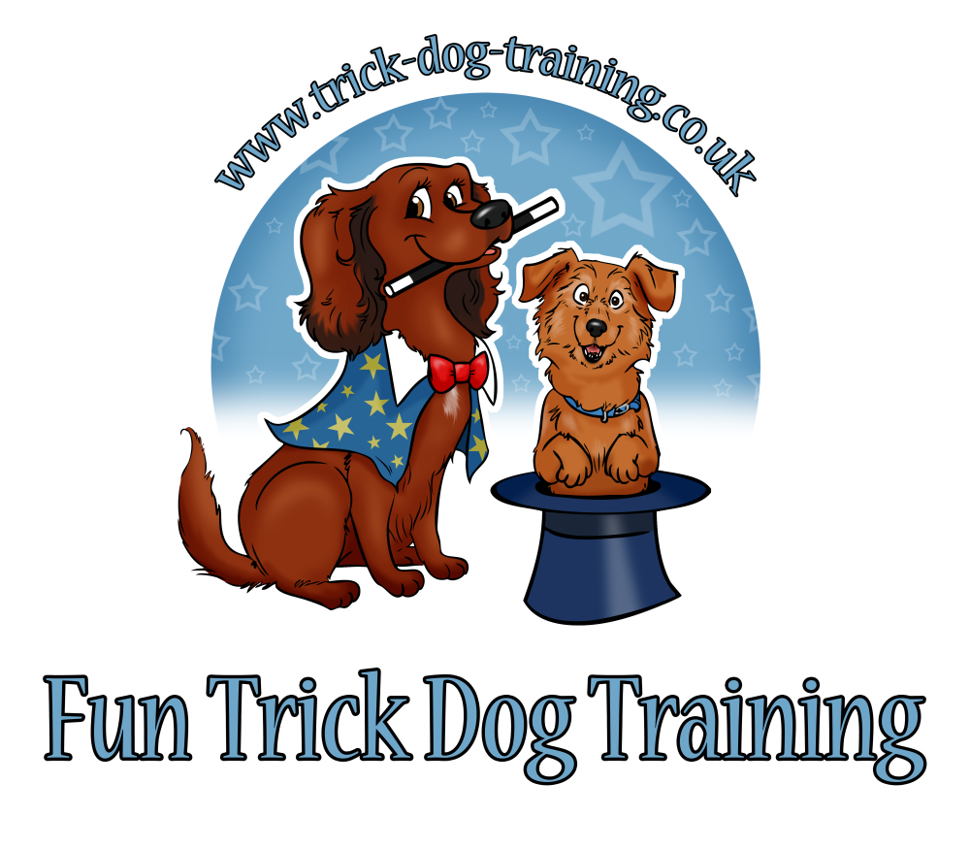

Name in Full:
Address in Full:
E-mail:
Dogs Name:
Breed:
Dogs Age:
Any mobility, disabilities or considerations?
How will the video be submitted? | YouTube Facebook DVD E-mail Other:
MPA Level applying for:
What is your preferred method of payment?

If paying by cheque: please make payable to Kathleen Tepperies

Full cost of certificate/s. | £  A confirmation will be send once payment received in full.  PLEASE NOTE: THERE ARE NO REFUNDS.  This does not affect your statutory rights.
If paying by BACS transfer please make payable to  Account: 39130968  Sort Code: 30 59 55 | If paying by BACS please use your surname as a reference.
Signature, date: | Please sign in this box if you are posting this booking form.  If you are sending by email please type in your name.  Completion and payment for this certificate confirms that you have read and comply with the Terms and Conditions; it is your responsibility that you have done so.

1. Read terms & conditions
2. Fill out the registration form
3. Send registration form via email or mail to:
funtrickdog@gmail.com
If send via post please ask for address
4. You may pay via cheque, payable to Kathleen Tepperies
Please ask for address
5. You may pay via BACS to Kathleen Tepperies
Account: 39130968
Sort Code: 30 59 55
If international bank transfer please ask for IBAN & BIC
5. You may pay via PayPal
funtrickdog@gmail.com
6. Send your video either via YouTube link, Facebook (private message), DVD, E-mail or other (dropbox etc)

Magic Pooch Awards Terms & Conditions:

- Any dogs can take part from 6 months onwards
- Any breed can take part (should the trick not be suitable for your breed, tricks can be changed after agreement)
- Force free training is a must. If your dog looks unhappy, fearful or shows any signs of being stressed (ears low, tail tucked between legs, avoiding handler/situation, yawing, whale eye) the certificate will not be awarded.
- Only positive methods accepted (no corrections, choke chains, electric collars or physical punishment)
- Tricks can be shown on a verbal or visual cue (or both)
- Rewards should be given after the trick is performed
- No luring for any of the levels (if you still need to lure your dog then he/she is not ready to perform the trick on a cue)
- The cue should not be given more than three times
- Handler and dog(s) must be clearly seen
- Clear videos with enough light
- No music and no mute (need to hear the cue)
- Entry Fee: £25 per level/per dog
- You will receive a written evaluation with the certificate and trophy should you pass.
- If something wasn’t quite there yet you have 3 months to improve the trick/s.
- Have fun and enjoy!

